**Module 4**

**Q-1 What are the main factors that can affect PPC bidding?**

**A-1** Here are the main factors that can affect PPC bidding:

### **1. Quality Score**

* Google Ads assigns a **Quality Score (1–10)** based on **CTR, ad relevance, and landing page experience**.
* Higher Quality Score = lower CPC for the same ad position.

### **2. Competition (Industry & Keywords)**

* Highly competitive industries (finance, legal, real estate) or keywords (like “insurance”) cost more.
* The number of advertisers bidding on the same keyword directly impacts CPC.

### **3. Keyword Match Type**

* **Exact match** keywords usually cost more but are highly targeted.
* **Broad match** may be cheaper per click but attract irrelevant traffic, wasting budget.
* **Phrase match** balances cost and relevance.

### **4. Geographic Location**

* CPC varies by region — competitive cities (e.g., New York, Mumbai) have higher bids compared to smaller towns.
* Running location-based campaigns can optimize costs.

### **5. Device Targeting**

* Bids can differ between **desktop, mobile, and tablet**.
* For example, mobile clicks might be more expensive in some niches (like food delivery or ride-hailing).

### **6. Ad Rank & Extensions**

* **Ad Rank = Bid × Quality Score × Expected Impact of Extensions**.
* Using sitelinks, callouts, structured snippets, and call extensions can improve Ad Rank and reduce cost.

### **7. Dayparting / Time of Day**

* CPCs fluctuate depending on time and day.
* Example: e-commerce brands often face higher competition during weekends or holidays.

### **8. Audience Targeting**

* Bids vary based on audience segments like demographics, interests, and remarketing lists.
* Narrower targeting = higher CPC but better conversions.

### **9. Ad Relevance & CTR**

* Ads with strong relevance and high CTR get rewarded with cheaper clicks.
* Poorly written or generic ads may require higher bids to compete.

### **10. Budget & Bidding Strategy**

* Automated bidding strategies (e.g., **Maximize Conversions**, **Target CPA**, **Target ROAS**) adjust bids dynamically.
* Manual CPC gives more control but requires monitoring.

**Q-2 How does a search engine calculate actual CPC?**

**A-2** The Actual CPC (Cost-Per-Click) you pay in Google Ads (and most PPC platforms) is not equal to your maximum bid. Instead, it’s determined by the Ad Rank formula. Let’s break it down:

### **🔹 Step 1:** Understand Ad Rank

Ad Rank = Bid × Quality Score × (Ad Extensions & other factors)

* Higher Ad Rank = higher ad position.
* It’s not just about bidding higher—better ad quality can beat higher bids.

### **🔹 Step 2:** Formula for Actual CPC

Google uses a second-price auction system. That means you usually pay just enough to beat the advertiser below you, not your full max bid.

The formula is:

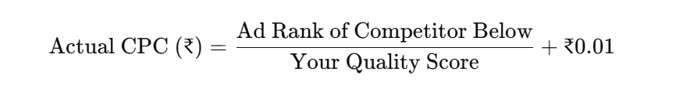

### **🔹 Step 3:** Example

Let’s say 3 advertisers are bidding on the same keyword:

| **Advertiser** | **Max Bid (₹)** | **Quality Score** | **Ad Rank (Bid × QS)** | **Position** | **Actual CPC (₹)** |
| --- | --- | --- | --- | --- | --- |
| A | ₹500 | 10 | 5000 | 1st | (4800 ÷ 10) + 0.01 = **₹480.01** |
| B | ₹800 | 6 | 4800 | 2nd | (3000 ÷ 6) + 0.01 = **₹500.01** |
| C | ₹1000 | 3 | 3000 | 3rd | Just above Google’s min. threshold (not full ₹1000) |

### **Key Observations:**

* Advertiser A bid ₹500 but pays only ₹480.01 because of the high Quality Score.
* Advertiser B bid ₹800 but pays only ₹500.01.
* Advertiser C doesn’t pay the full bid either — they pay just enough to clear Google’s minimum Ad Rank requirement.
* This shows how **Quality Score reduces cost-per-click significantly.**

### **🔹 Key Takeaways**

1. Better Quality Score = Lower CPC (even if competitors bid more).
2. You only pay slightly more than the competitor below you.
3. Extensions, CTR, and ad relevance improve Ad Rank → lower CPC.

**Q-3 What is a quality score and why is it important for Ads?**

**A-3** Quality Score is a Google Ads metric (1–10) which is explained further in following:

## **Quality Score:**

**Quality Score** is a rating (on a scale of **1 to 10**) given by Google Ads that measures the **relevance and quality** of your keywords, ads, and landing pages.

It is Google’s way of ensuring that users see **useful and relevant ads**, not just ads from the highest bidders.

## **Components of Quality Score**

Google calculates it based on three main factors:

1. **Expected Click-Through Rate (CTR)**
   * How likely people are to click your ad when they see it.
2. **Ad Relevance**
   * How closely your ad matches the searcher’s intent and keyword.
3. **Landing Page Experience**
   * Whether the page users land on isrelevant, useful, and user-friendly(fast loading, mobile-friendly, easy navigation).

## **Why Quality Score is Important**

1. **Lower Cost-Per-Click (CPC)**
   * Higher Quality Score = you pay less per click (because Google rewards relevance).
2. **Better Ad Rank**
   * Ad Rank = Bid × Quality Score × Extensions.
   * So even with a lower bid, you can outrank competitors with poor Quality Scores.
3. **Improved ROI**
   * You get more clicks for the same budget because your CPC is lower.
4. **More Visibility**
   * High Quality Score improves ad positions → your ad shows higher on the search results page.
5. **Better User Experience**
   * Since ads and landing pages are more relevant, users are more likely to engage, convert, and trust your brand.

## **Quick Example**

* **Advertiser A**: Max Bid ₹100, Quality Score **10** → Ad Rank = 1000
* **Advertiser B**: Max Bid ₹150, Quality Score **5** → Ad Rank = 750
* Even though Advertiser B bid higher, Advertiser A wins the top position because of better Quality Score — and pays less CPC.
* **In short:**Quality Score is Google’s way of rewarding advertisers for creating relevant, helpful, and high-performing ads.It saves you money, improves ad placement , and boosts user trust.

**Q-4 Create an ad for your website/ blog in Google Ads that display on the display network with the properly targeted audience.**

**A-4** This is a Display campaign named **Bootstrap Display Campaign** which is created on the blog site “<https://bootstrapguide2025.blogspot.com/>”. Following are the screenshots:  
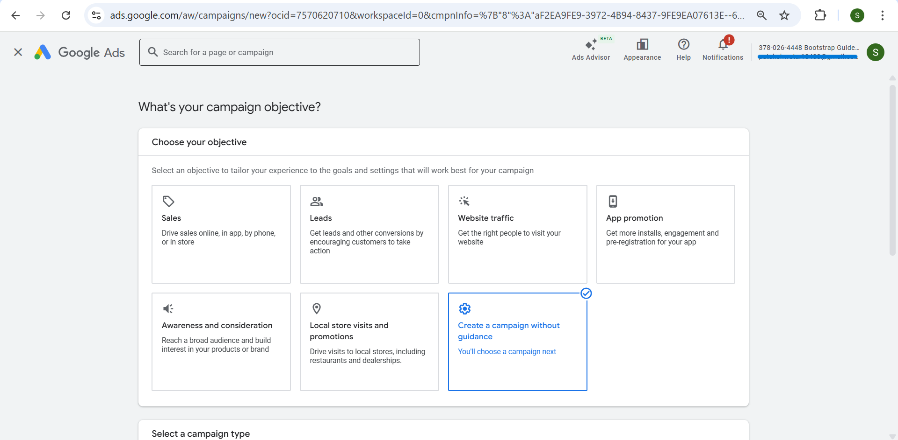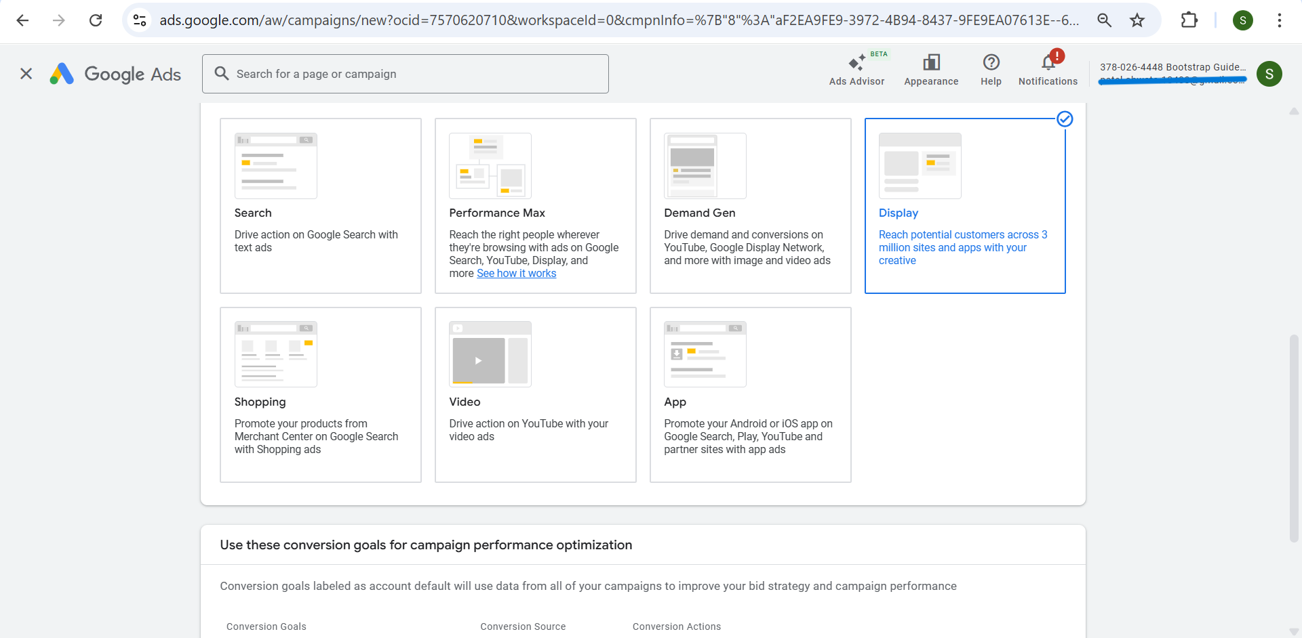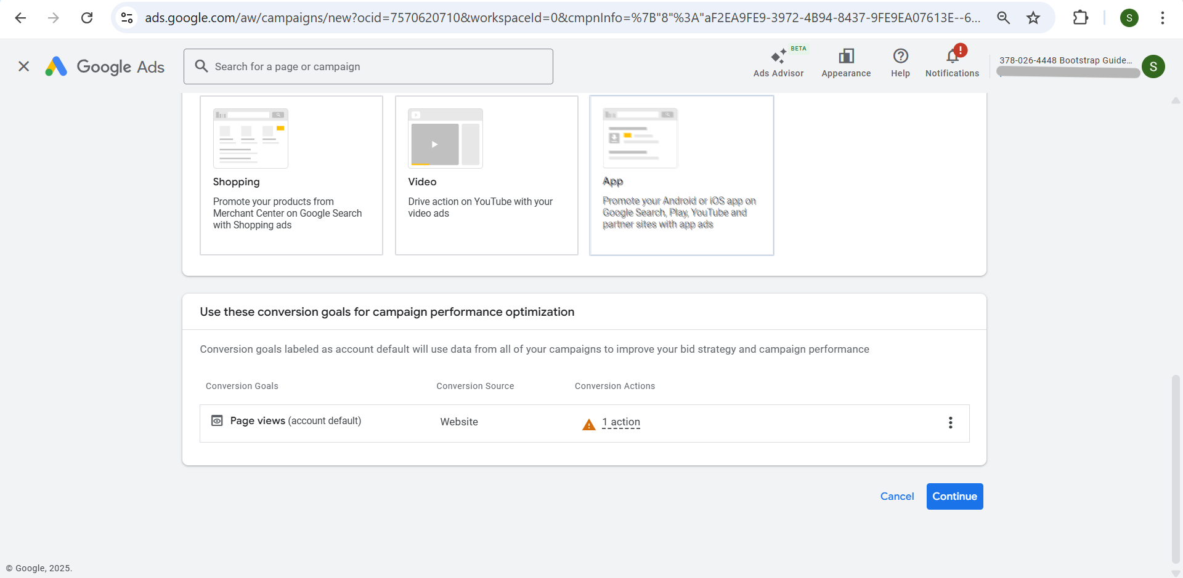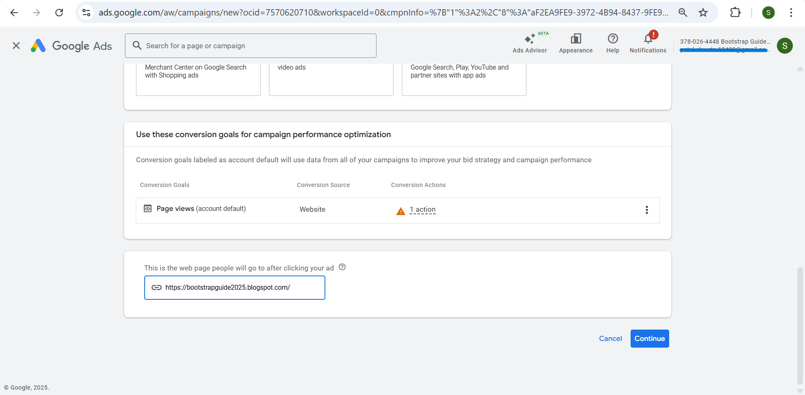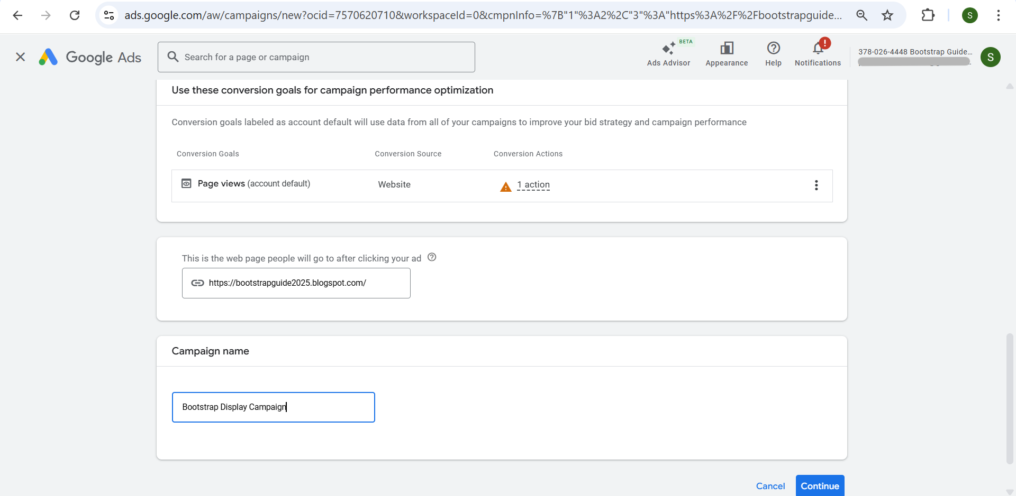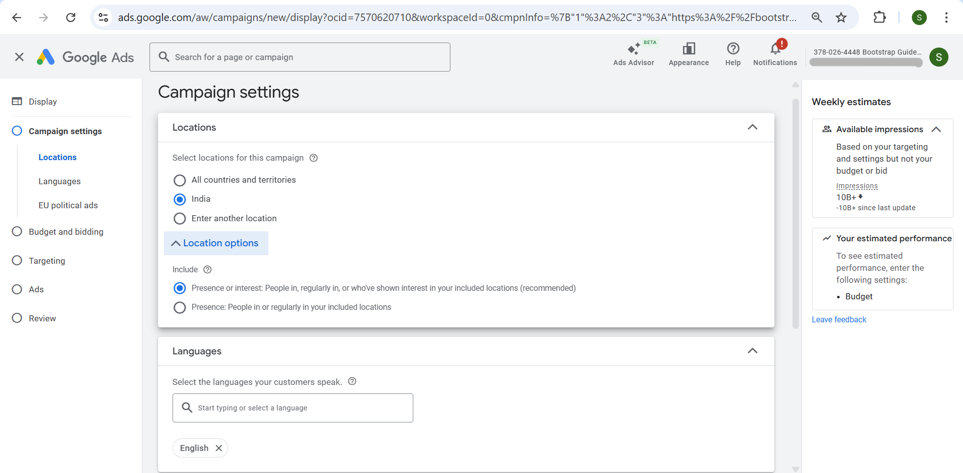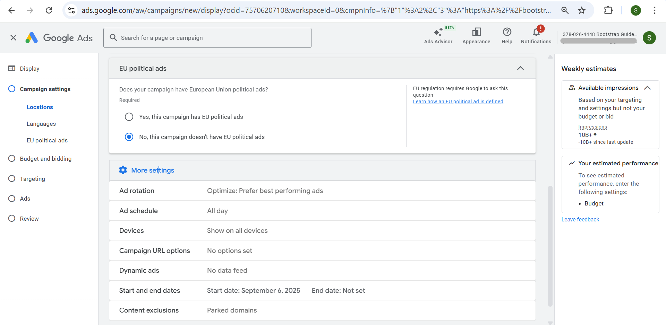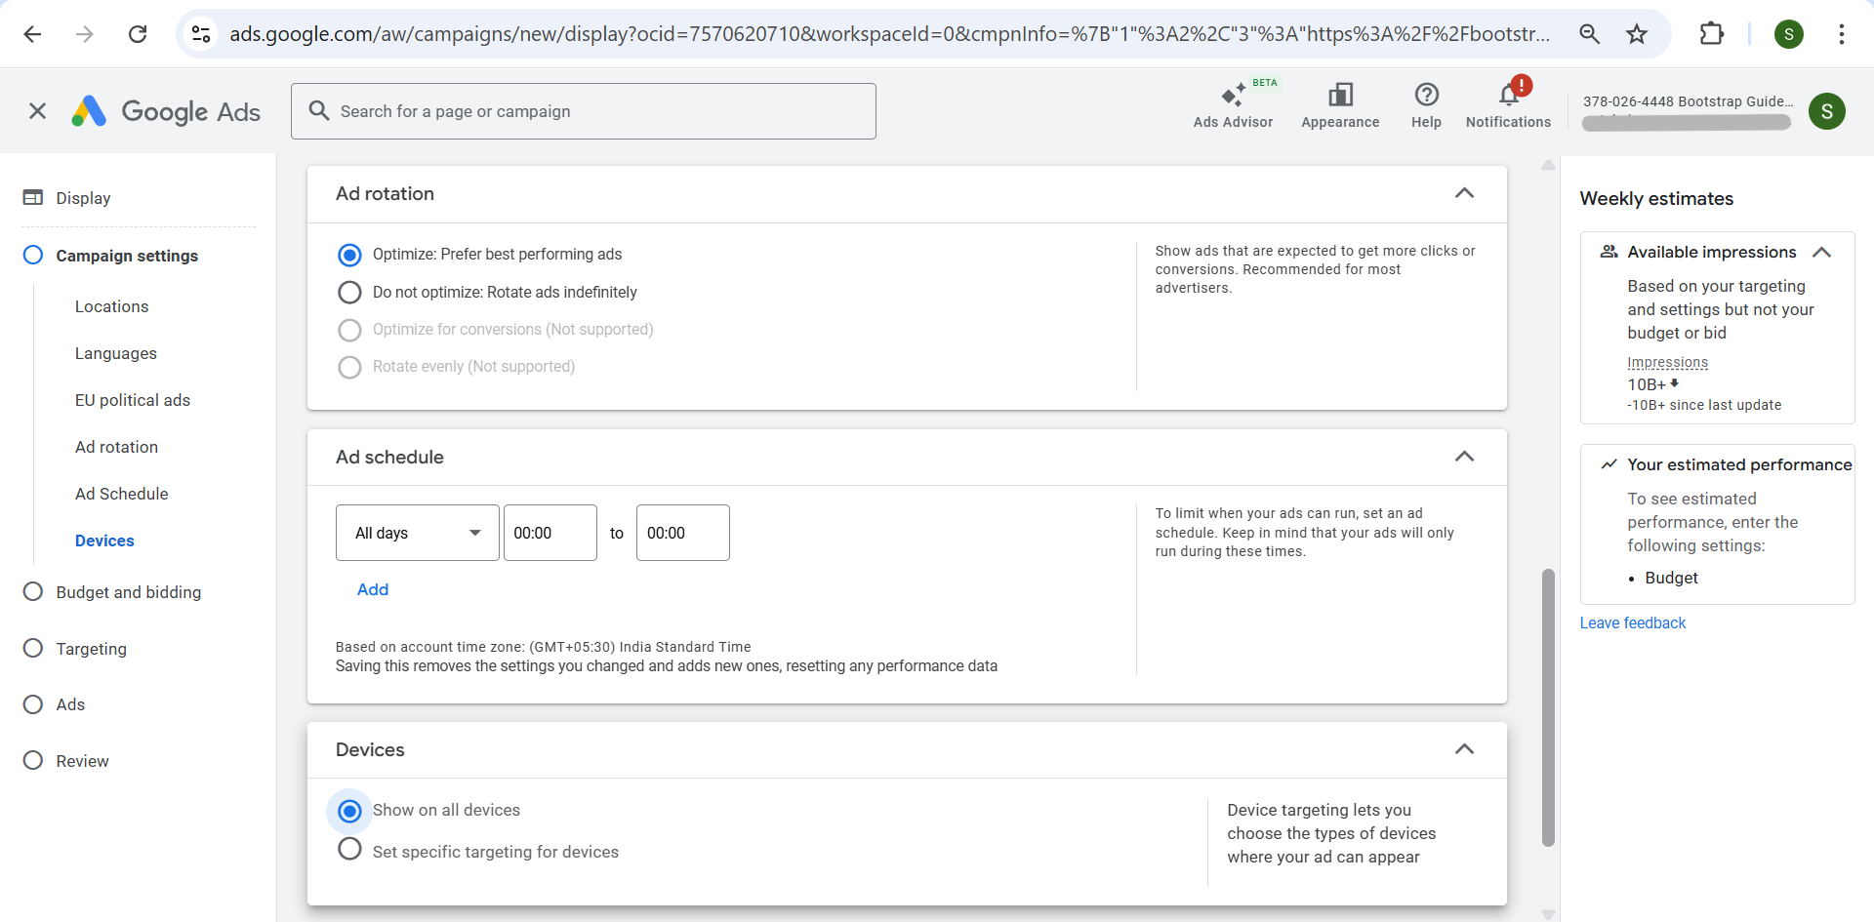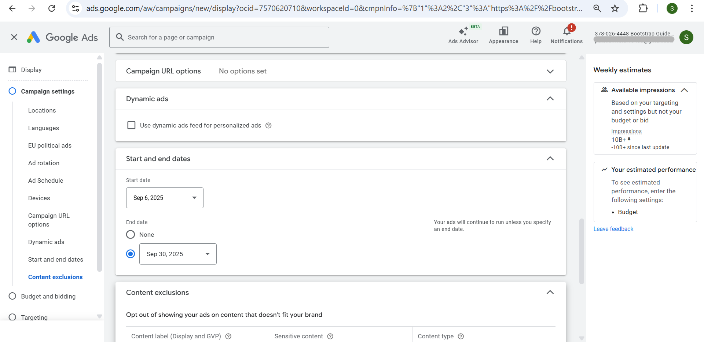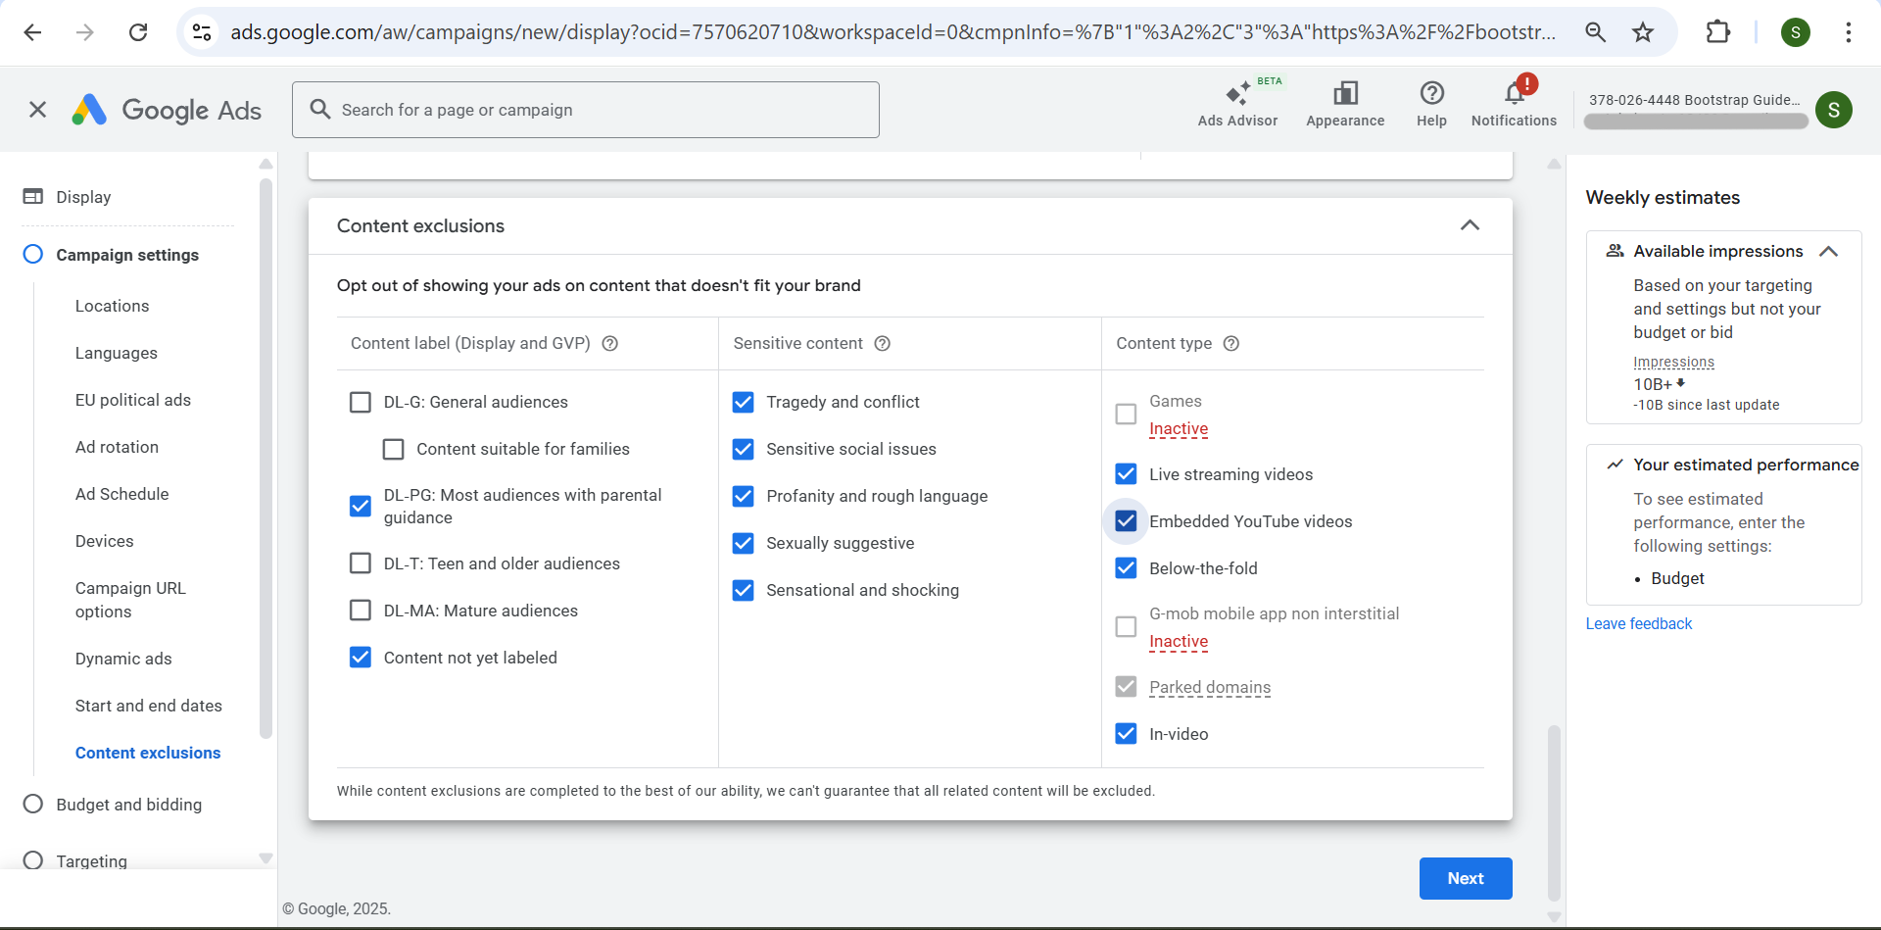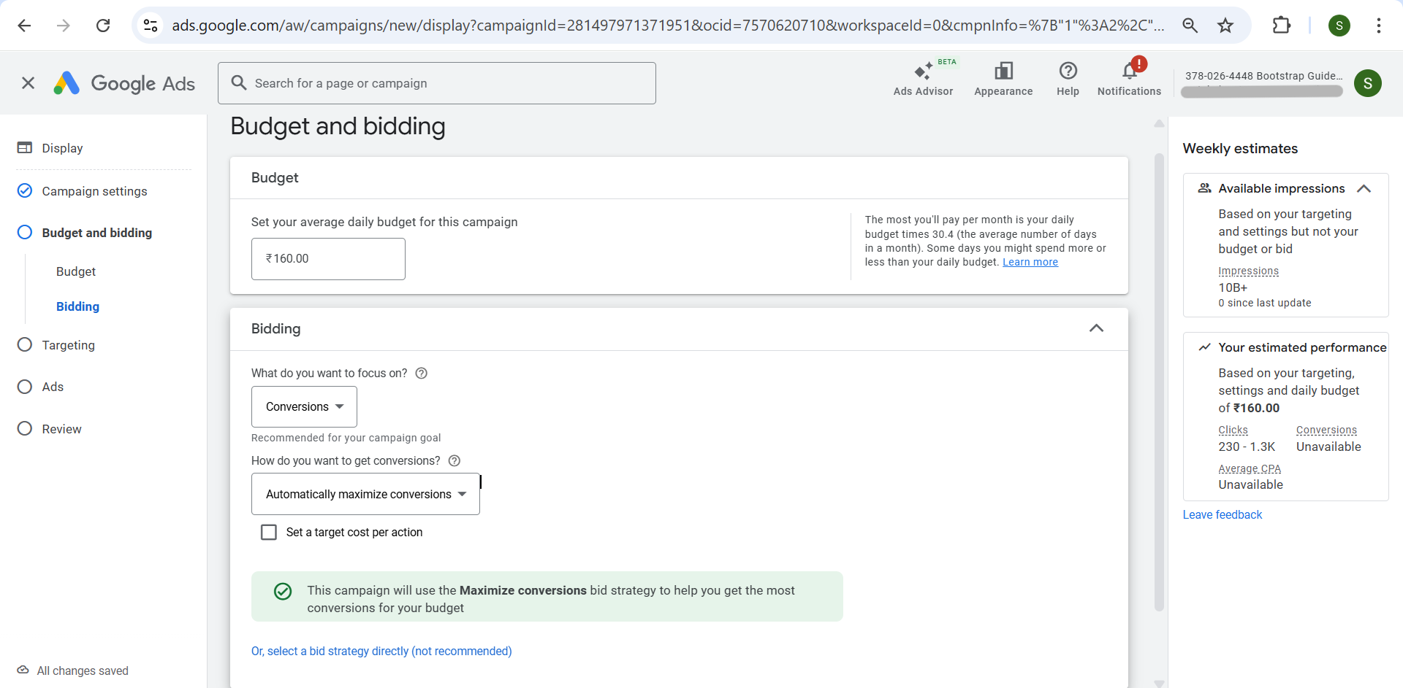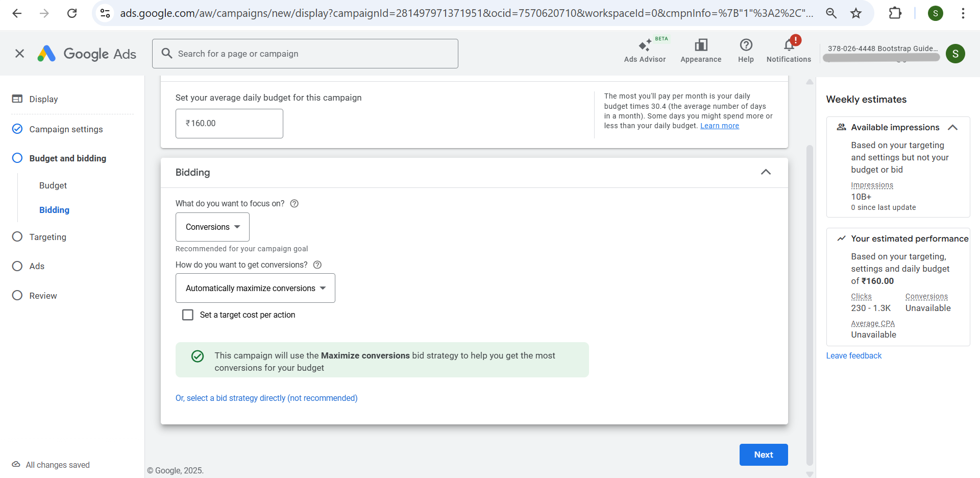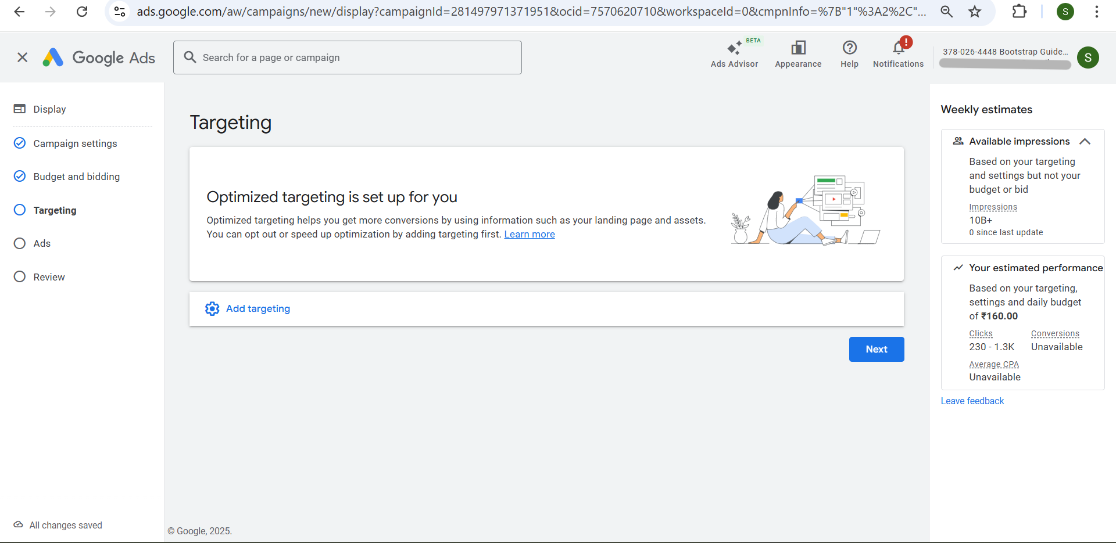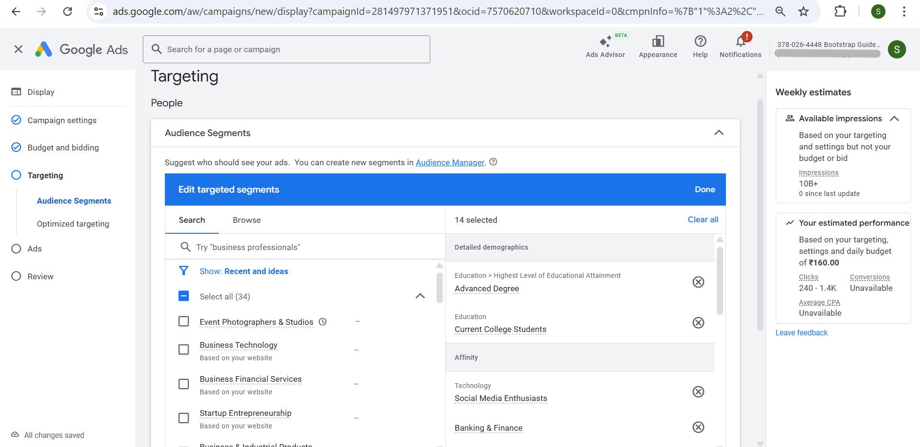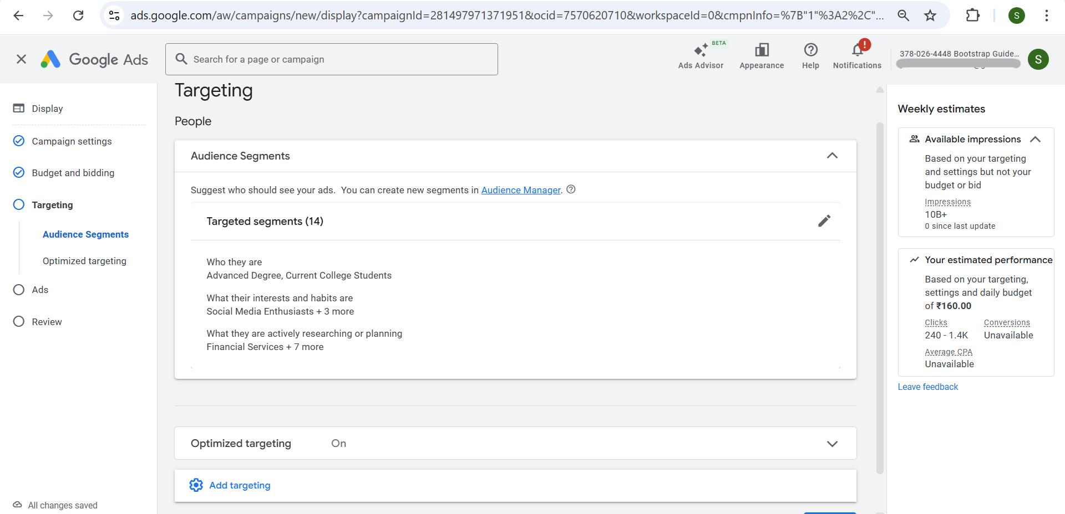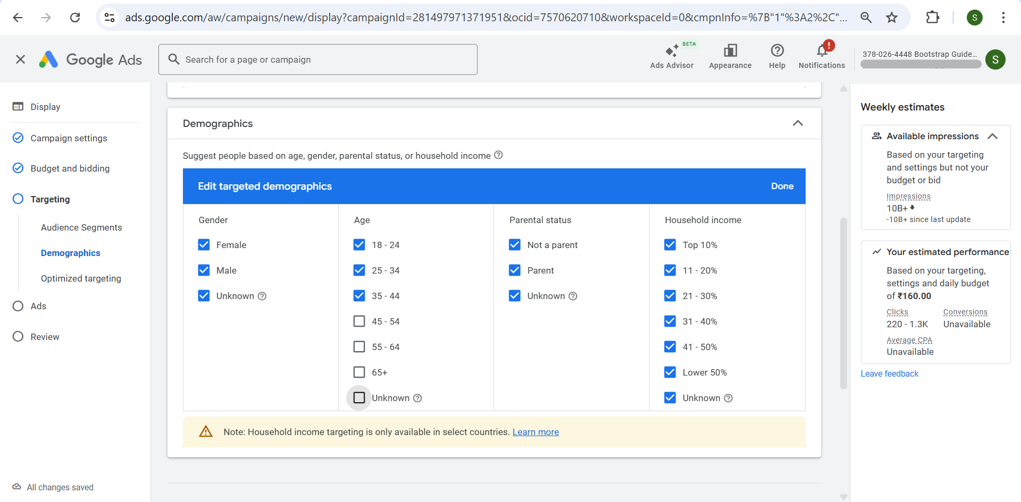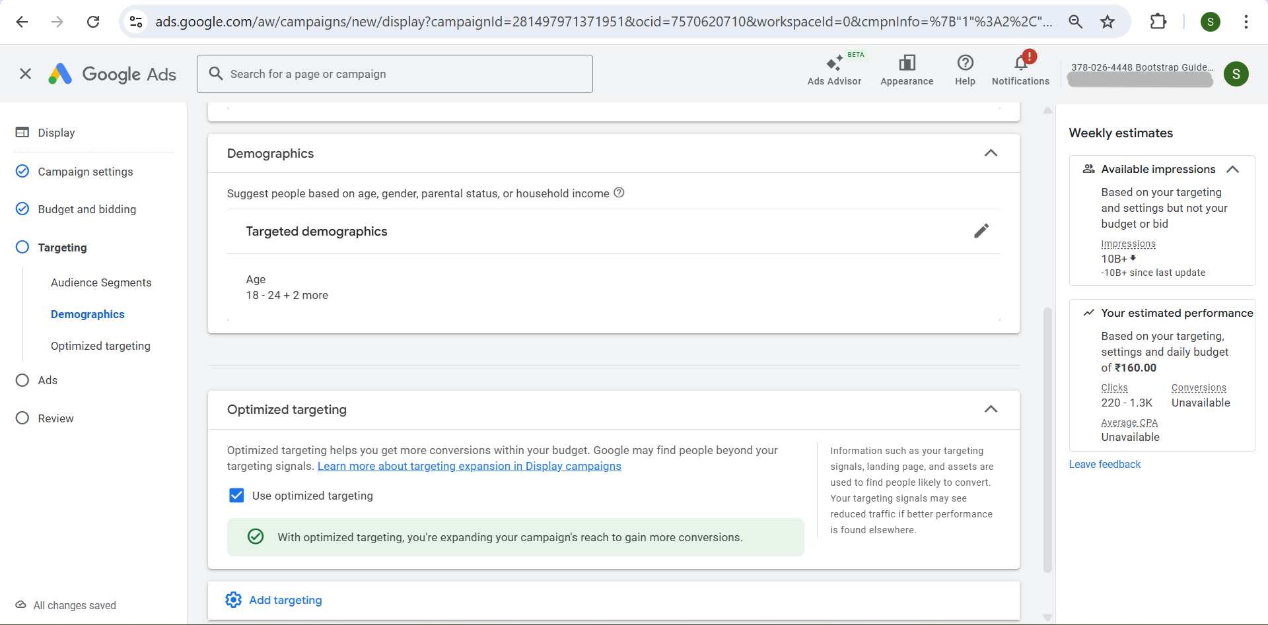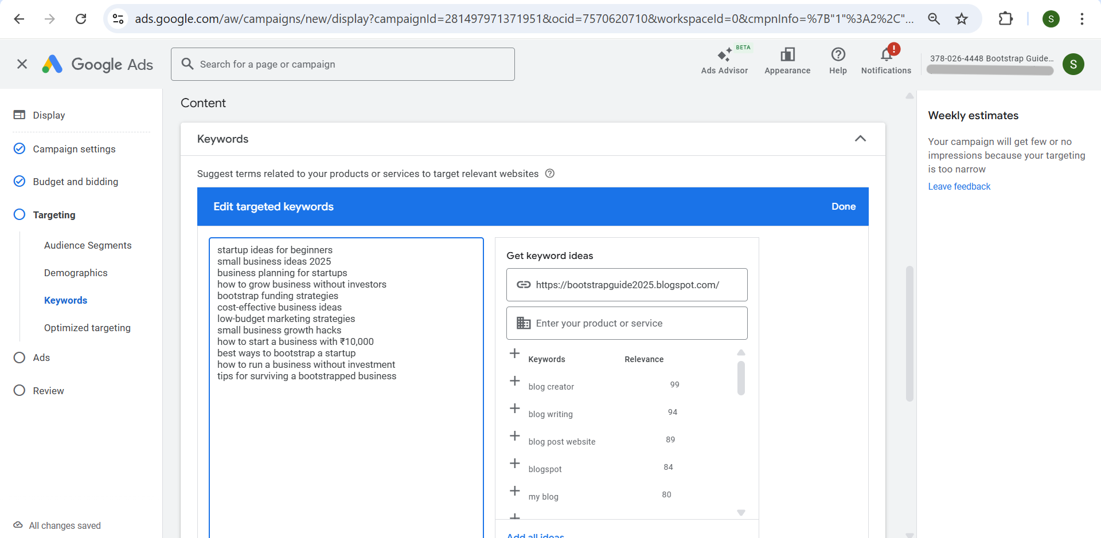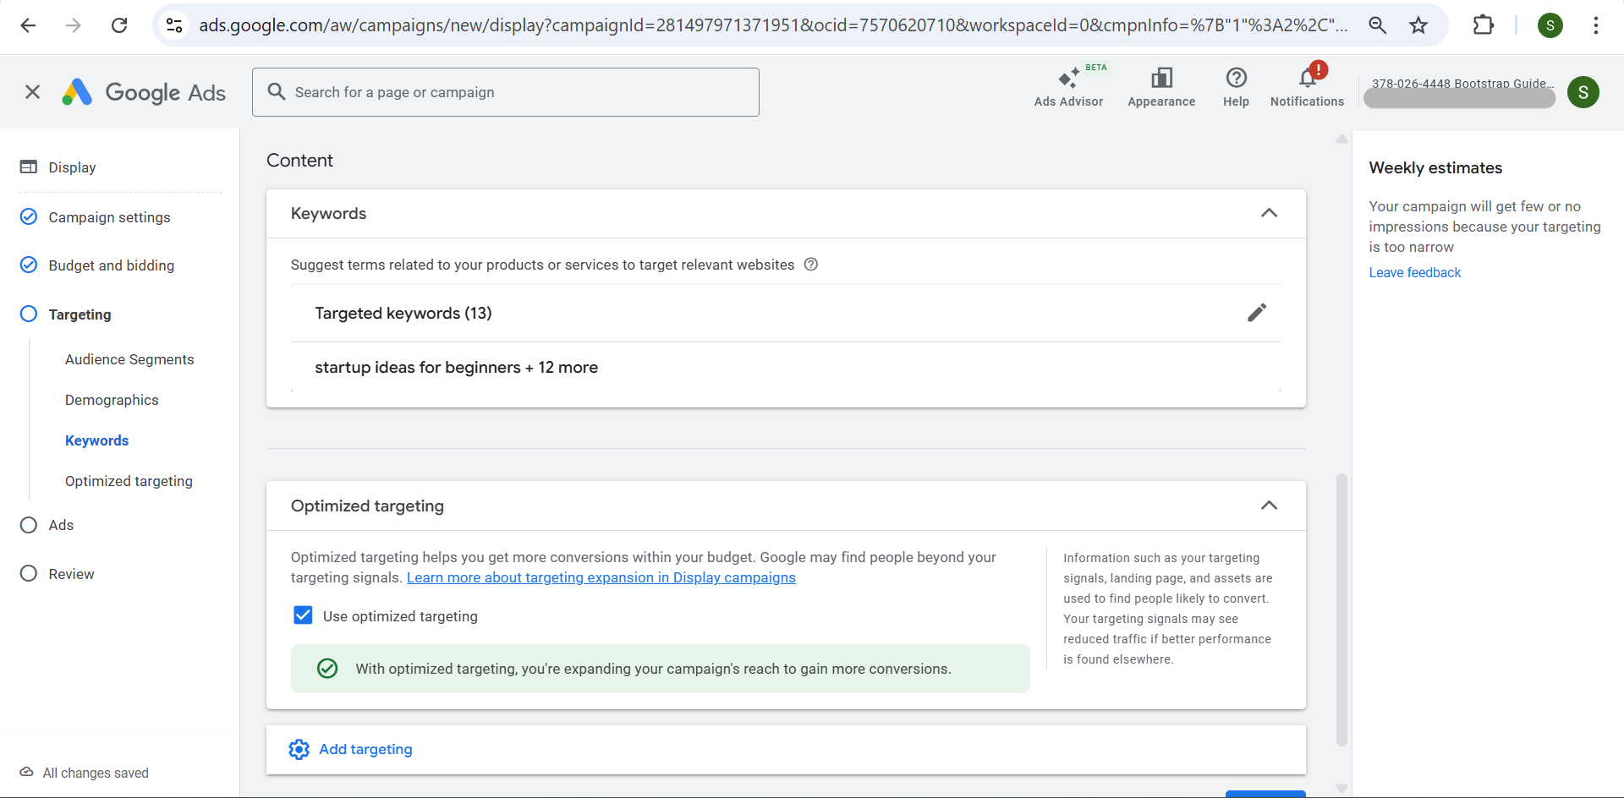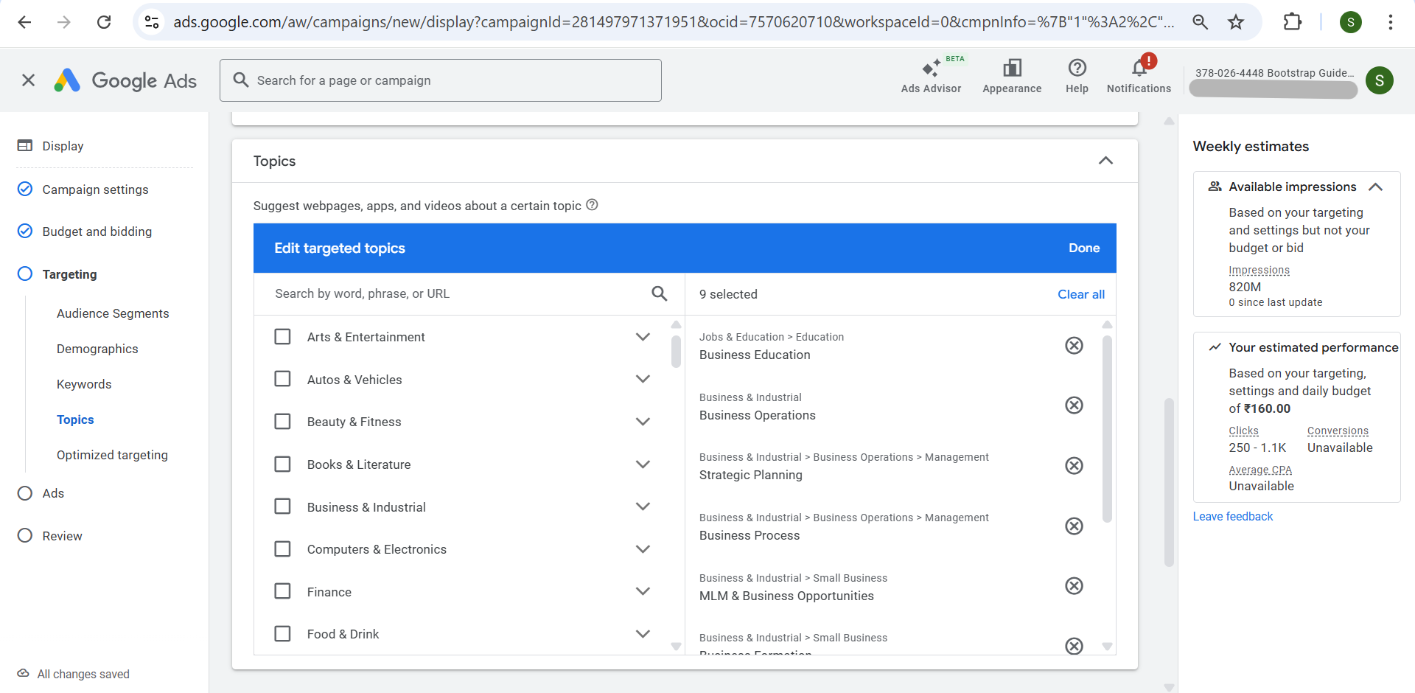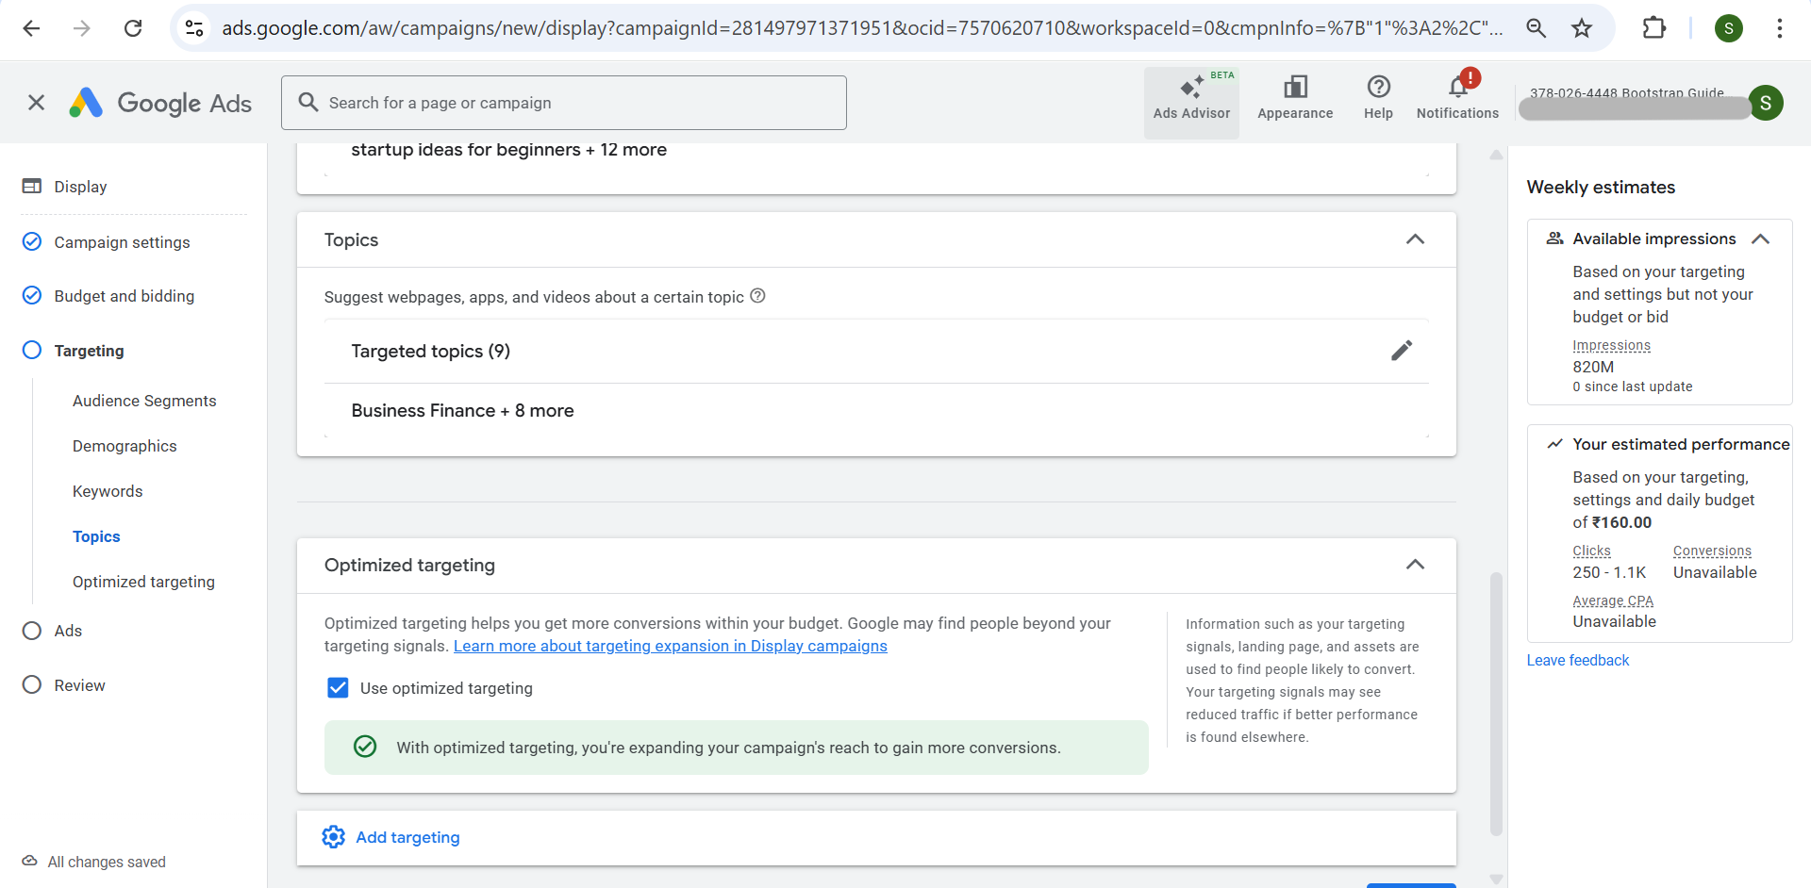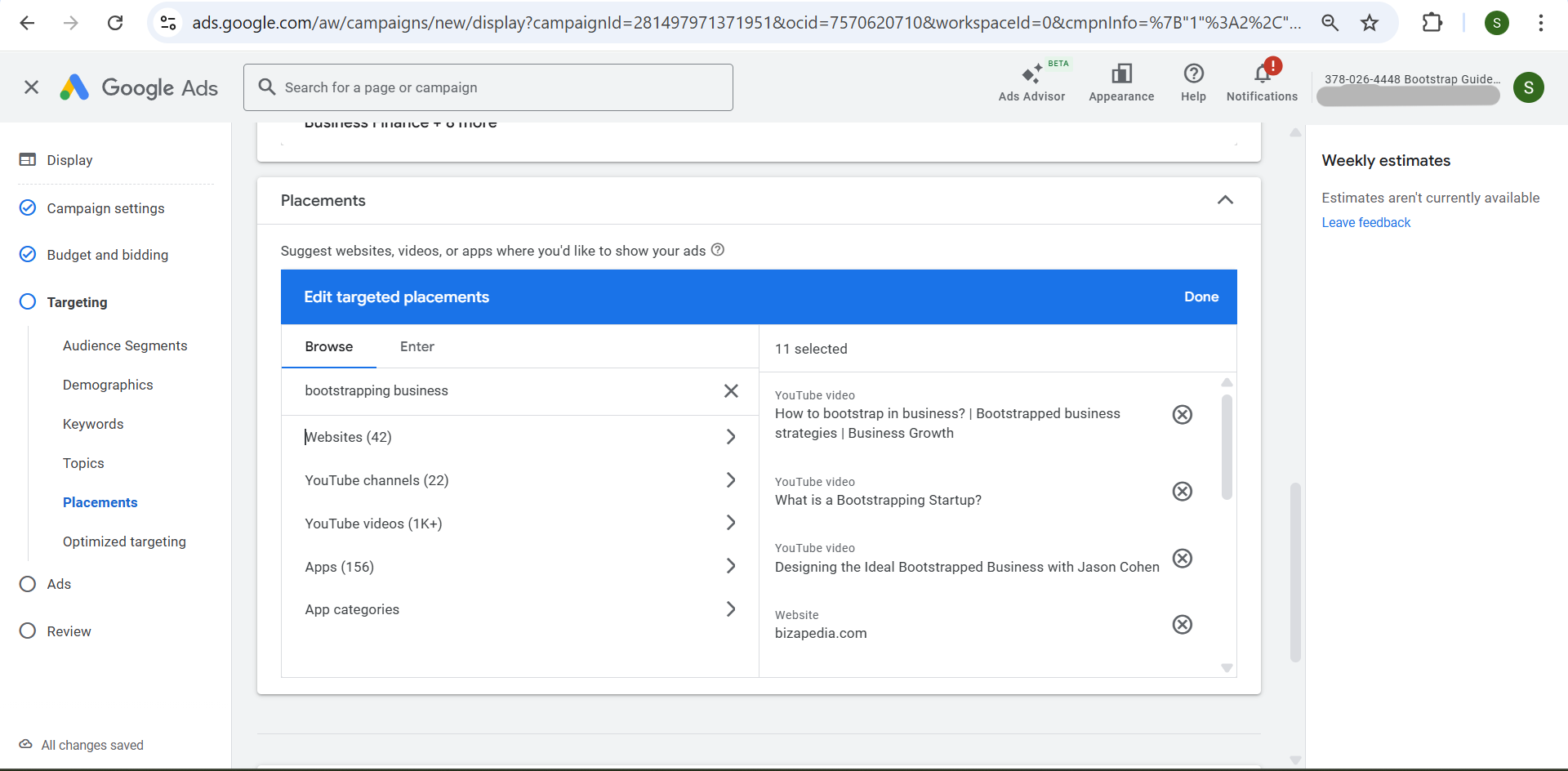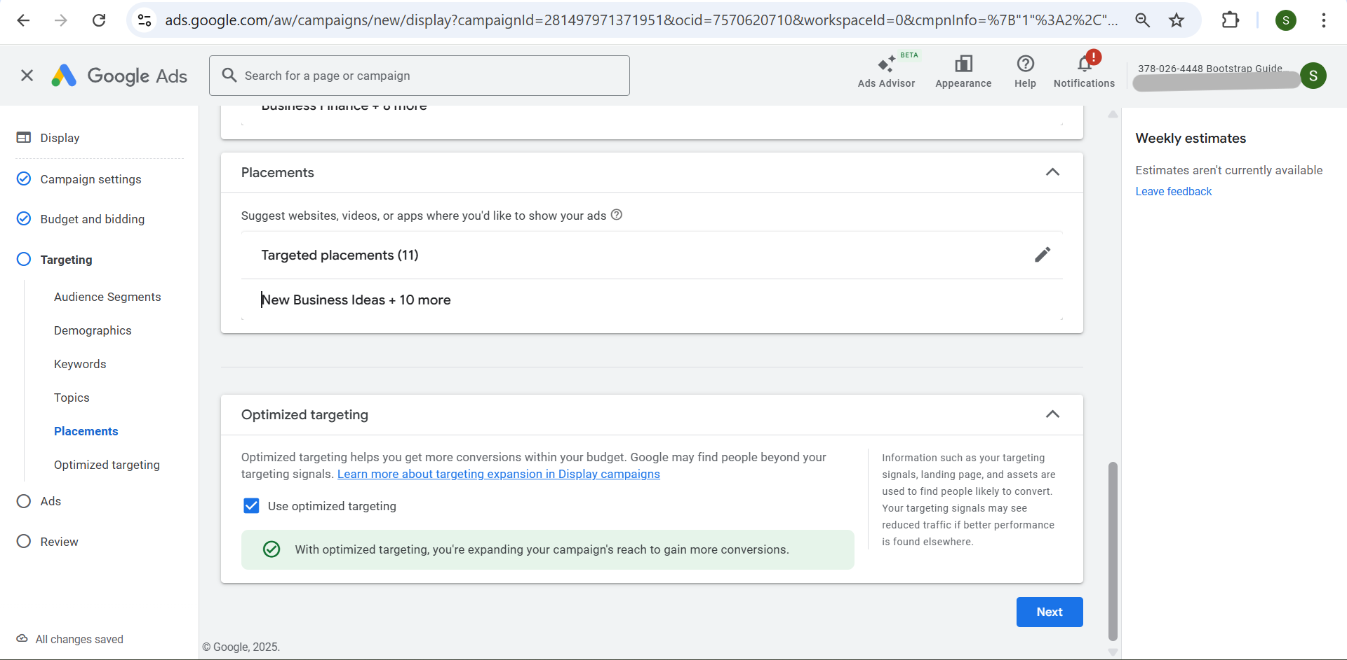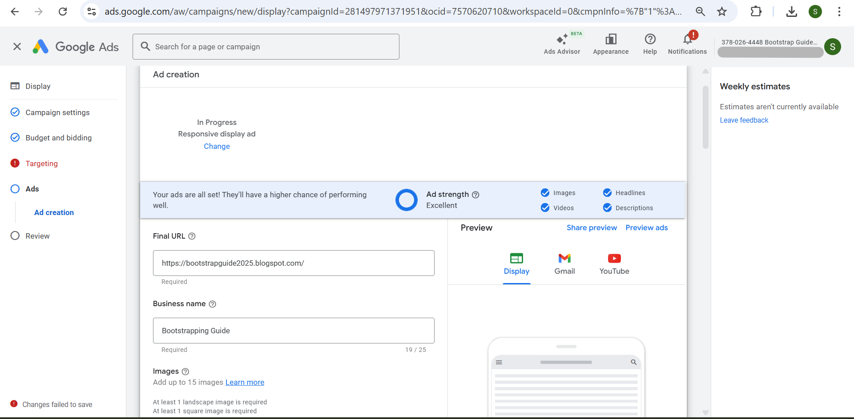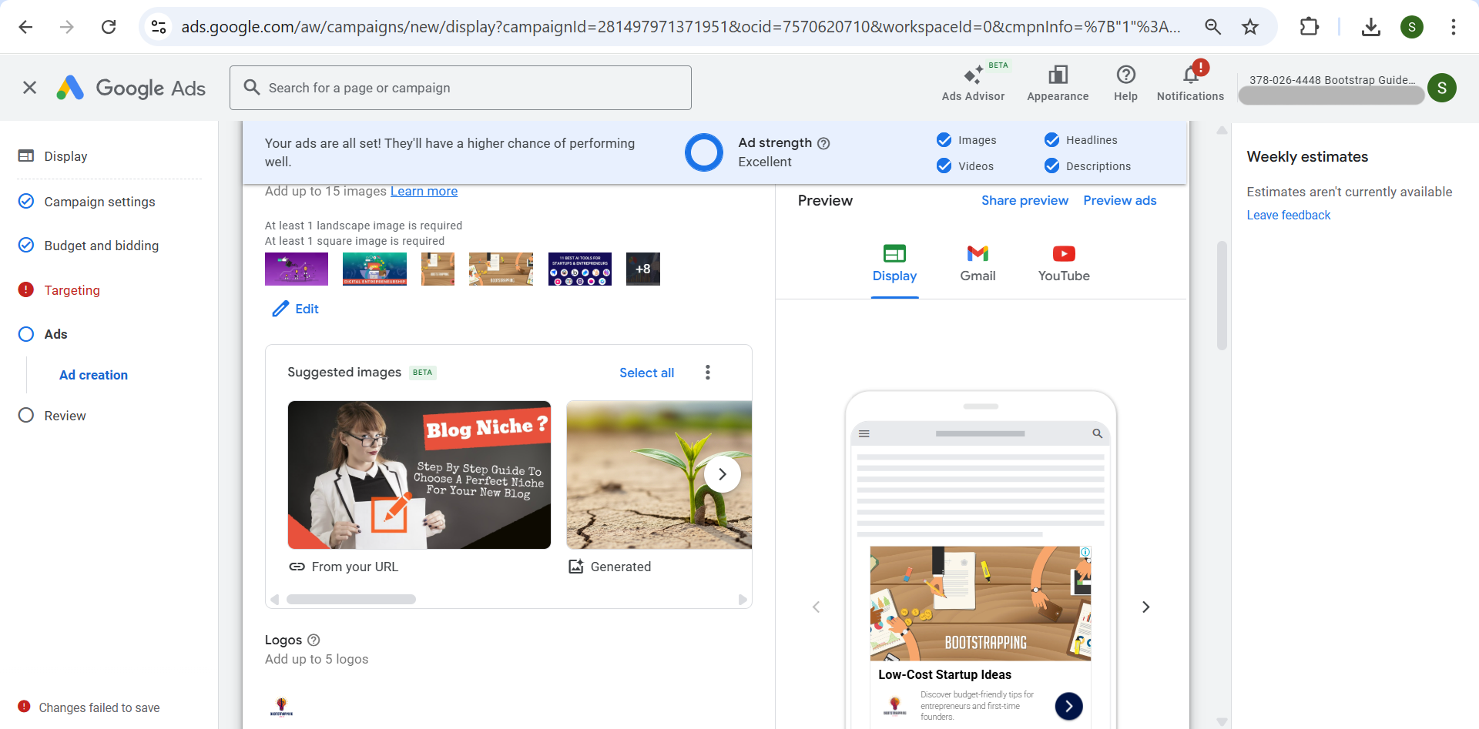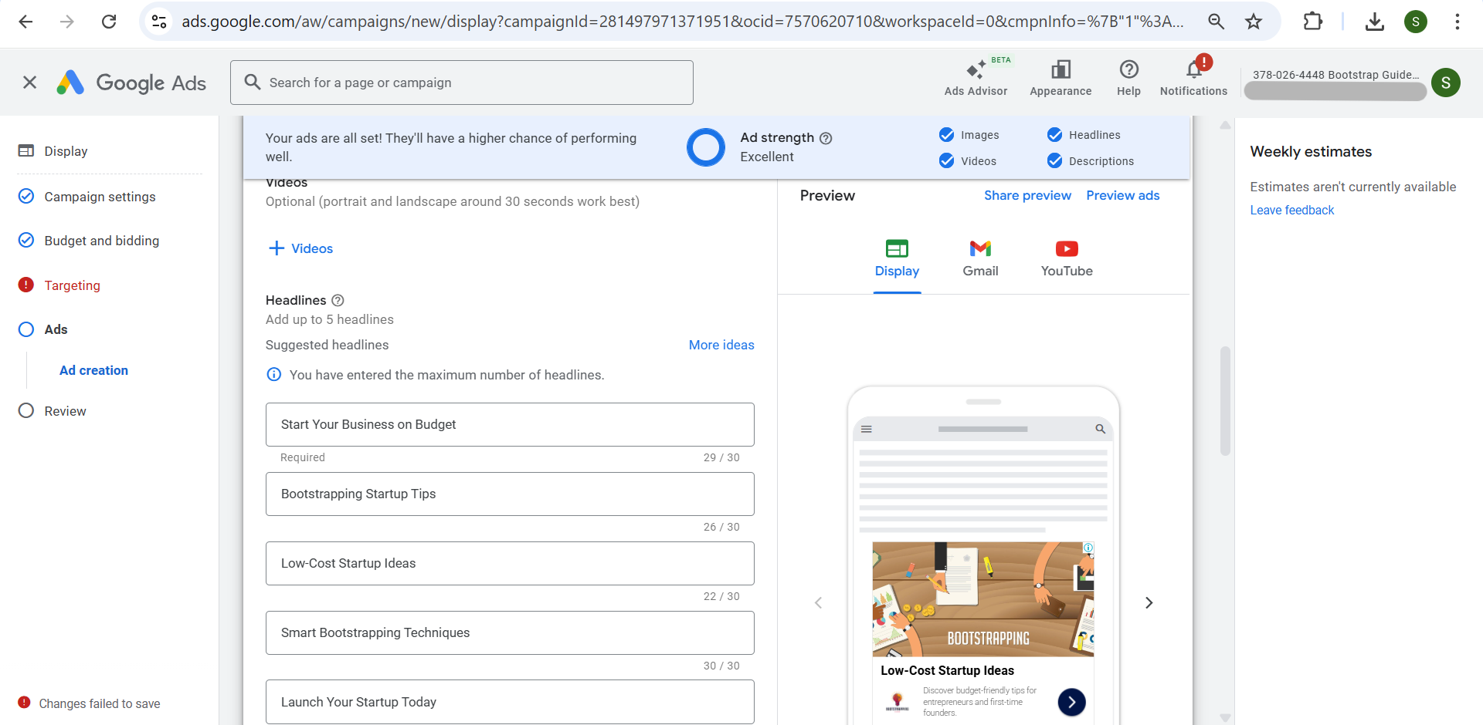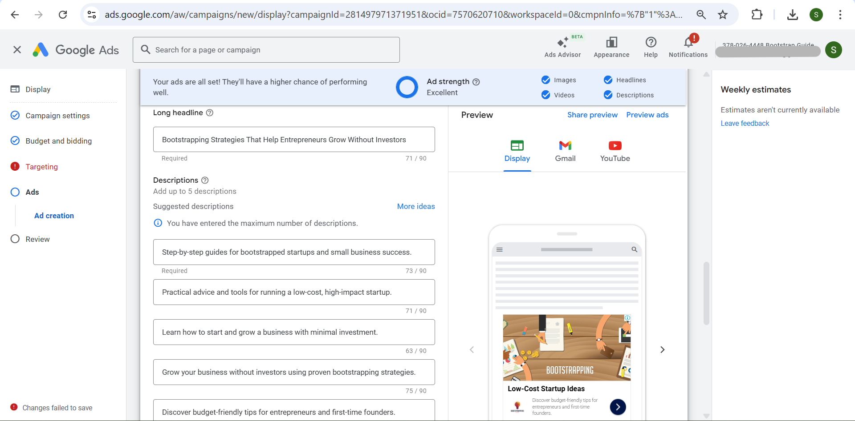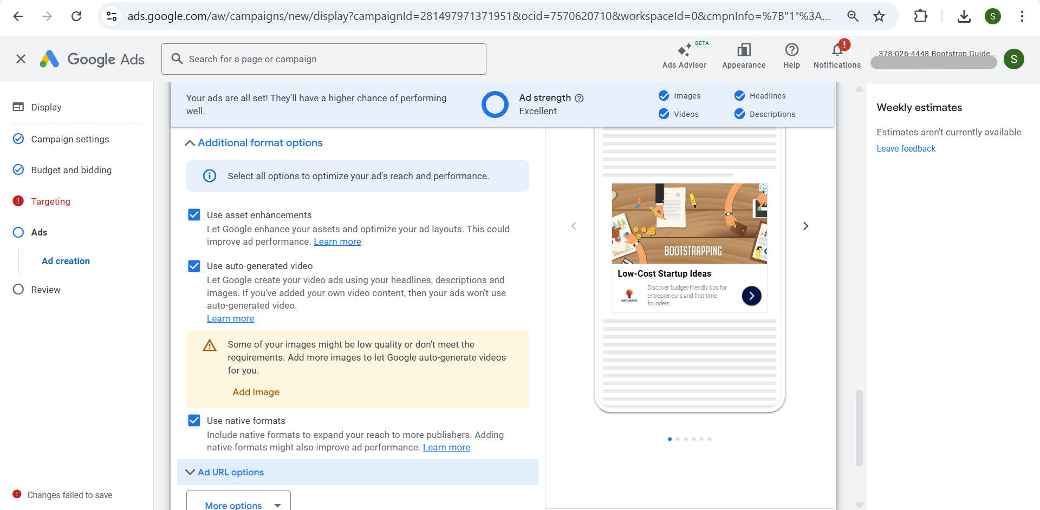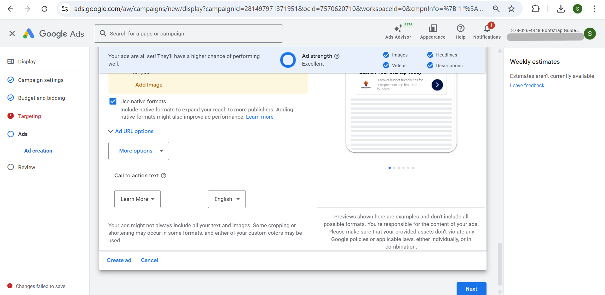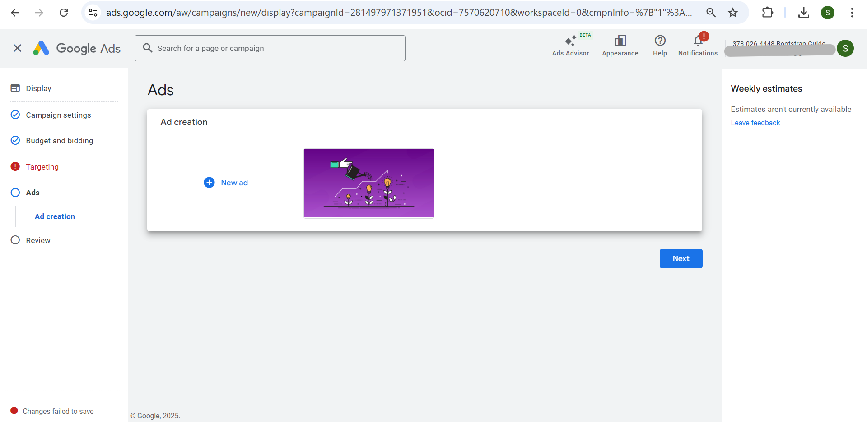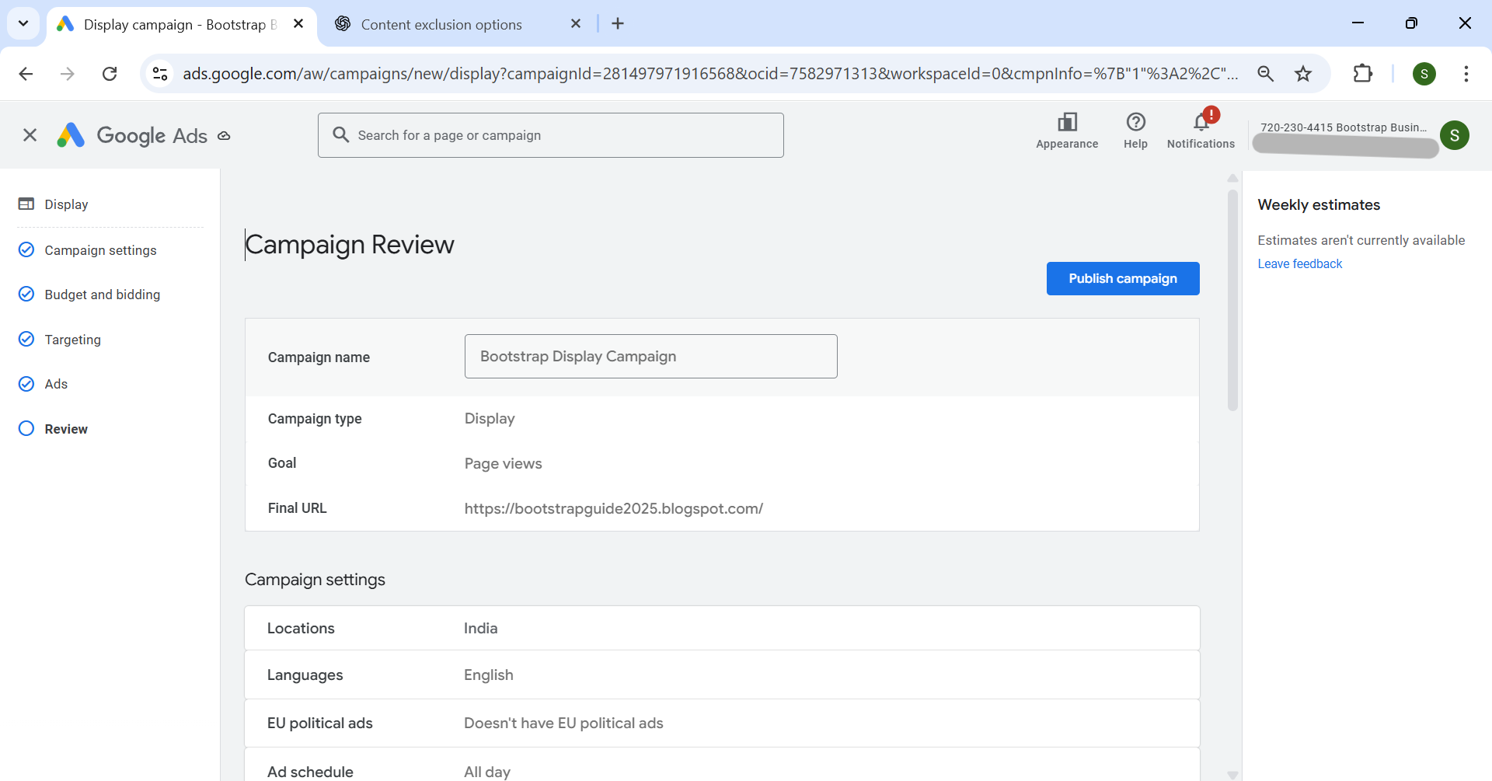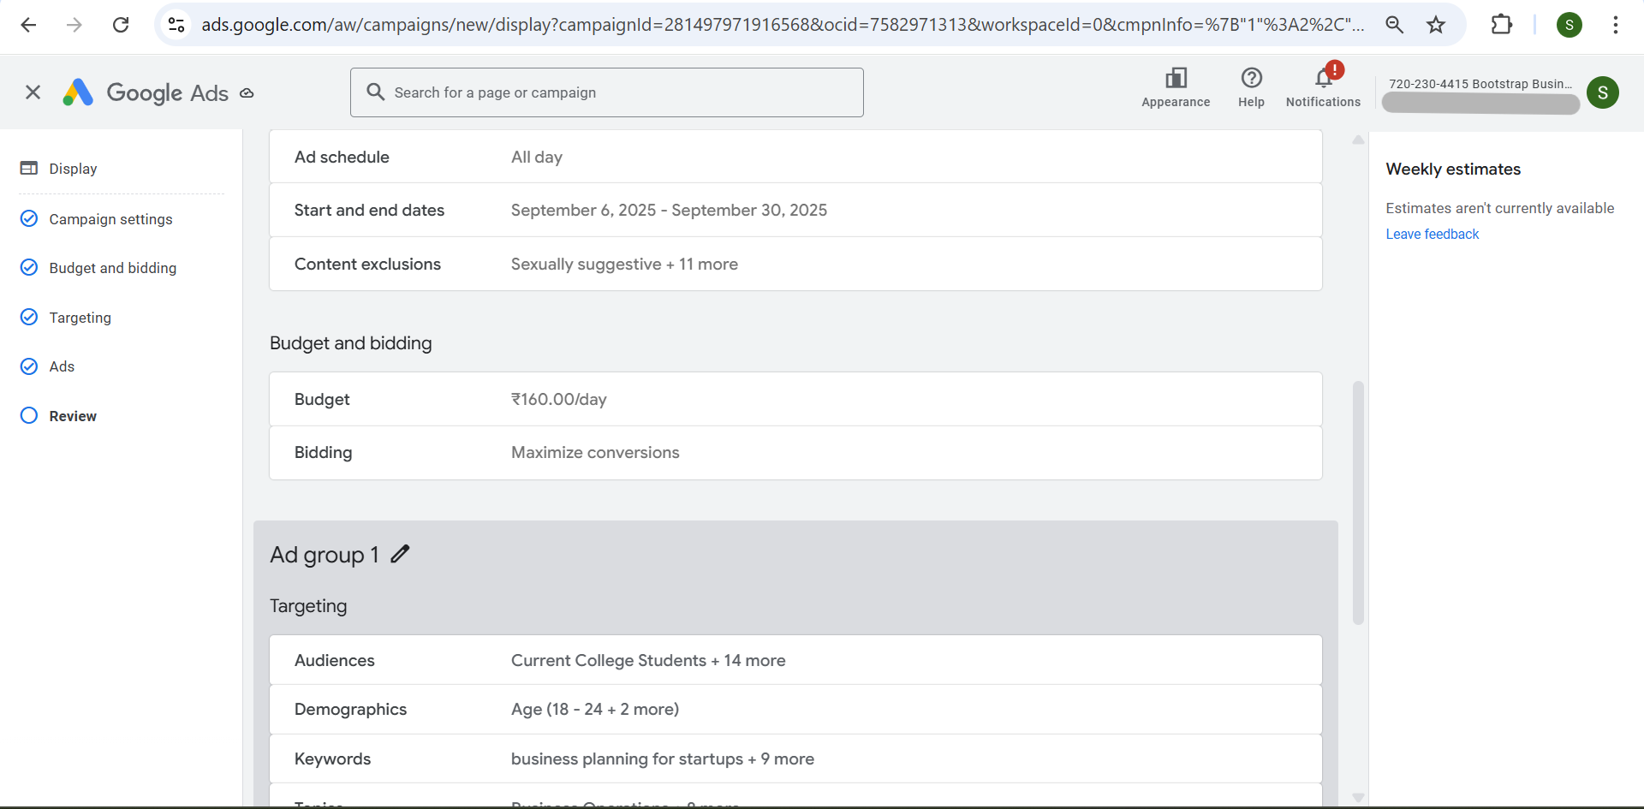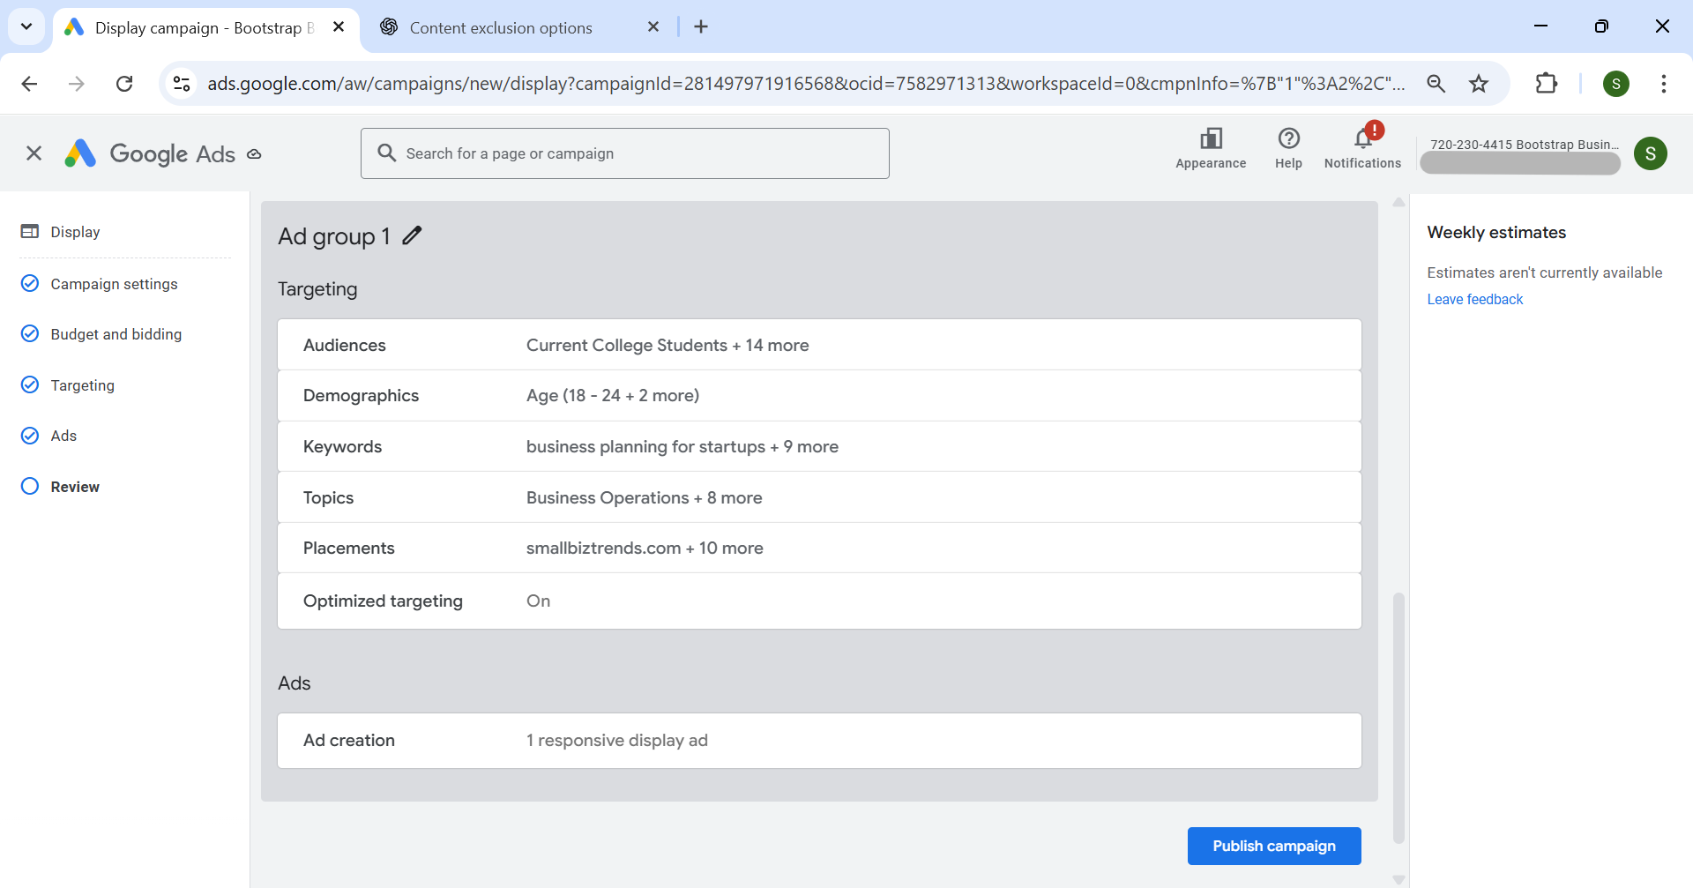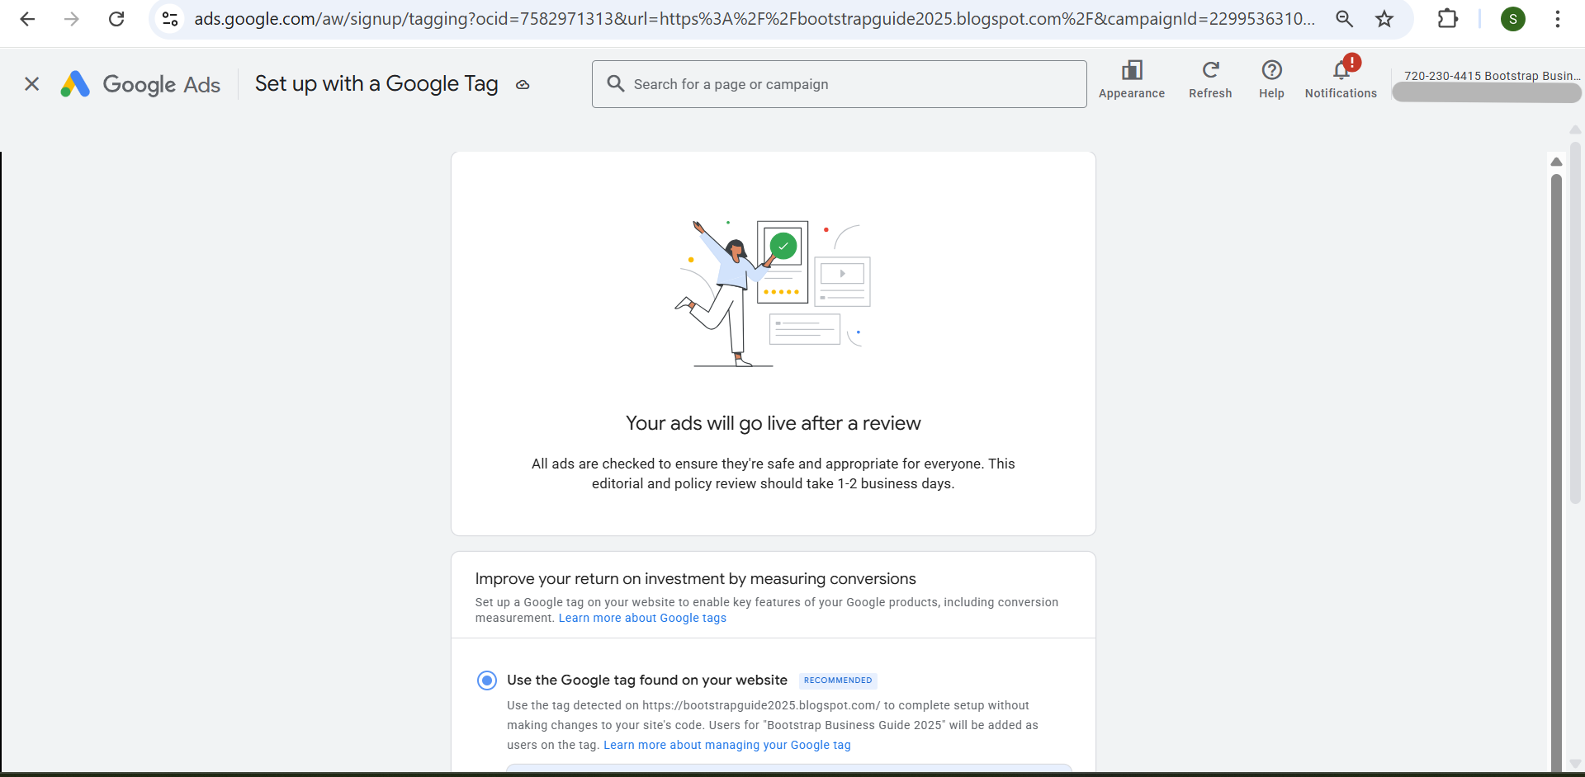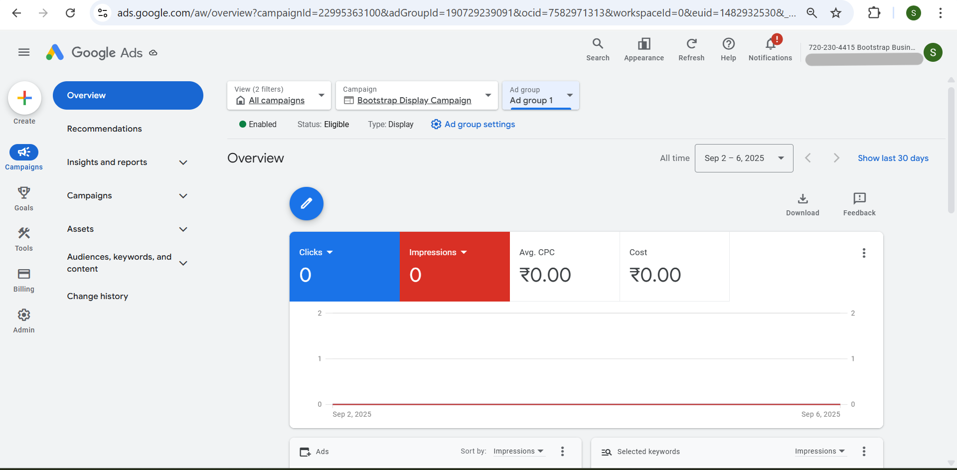

**Q-5 Create an ad for www.tops-int.com to get the maximum Clicks**

* **Choose a proper Target audience.**
* **Expected conversion: need maximum user engagement within the budget.**
* **Budget: 5000.**

**A-5** This is a Search campaign named **Tops Max Clicks User Engage Camp** for IT Training Institute “ [www.tops-int.com](http://www.tops-int.com)” to generate maximum clicks and user engagement within 5000 budget. Following are the screenshots:

